**DAILY ONLINE ACTIVITIES SUMMARY**

|  |  |  |  |  |  |  |  |  |
| --- | --- | --- | --- | --- | --- | --- | --- | --- |
| **Date:** | **22-05-2020** | | | | | **Name:** | **Kavya** | |
| **Sem & Sec** | **6th & A** | | | | | **USN:** | **4al17cs041** | |
| **Online Test Summary** | | | | | | | | |
| **Subject** | | **Operation Research** | | | | | | |
| **Max. Marks** | | **30** | | **Score** | | | **30** | |
| **Certification Course Summary** | | | | | | | | |
| **Course** | **Learn Flutter-Beginners Course** | | | | | | | |
| **Certificate Provider** | | | **Udemy** | | **Duration** | | | **2 hours** |
| **Coding Challenges** | | | | | | | | |
| **Problem Statement:1.** 1.Write a Java Program to separate the Individual Characters from a String  Description: In computer science, collection of characters including spaces is called as string. To separate an individual character from the string, individual characters are accessed through its index.  **2.** Write a Java Program to find the largest and smallest word in a string.  3. Write a C Program to implement various operations of Singly Linked List Stack | | | | | | | | |
| **Status:Yes, I Have completed all the programs** | | | | | | | | |
| **Uploaded the report in Github** | | | | | **yes** | | | |
| **If yes Repository name** | | | | | [**https://github.com/kavya-077/DAILY-STATUS**](https://github.com/kavya-077/DAILY-STATUS) | | | |
| **Uploaded the report in slack** | | | | | **yes** | | | |

Online Test Details: (Attach the snapshot and briefly write the report for the same)

OPERATION RESEARCH

MARKS SCORED:30/30

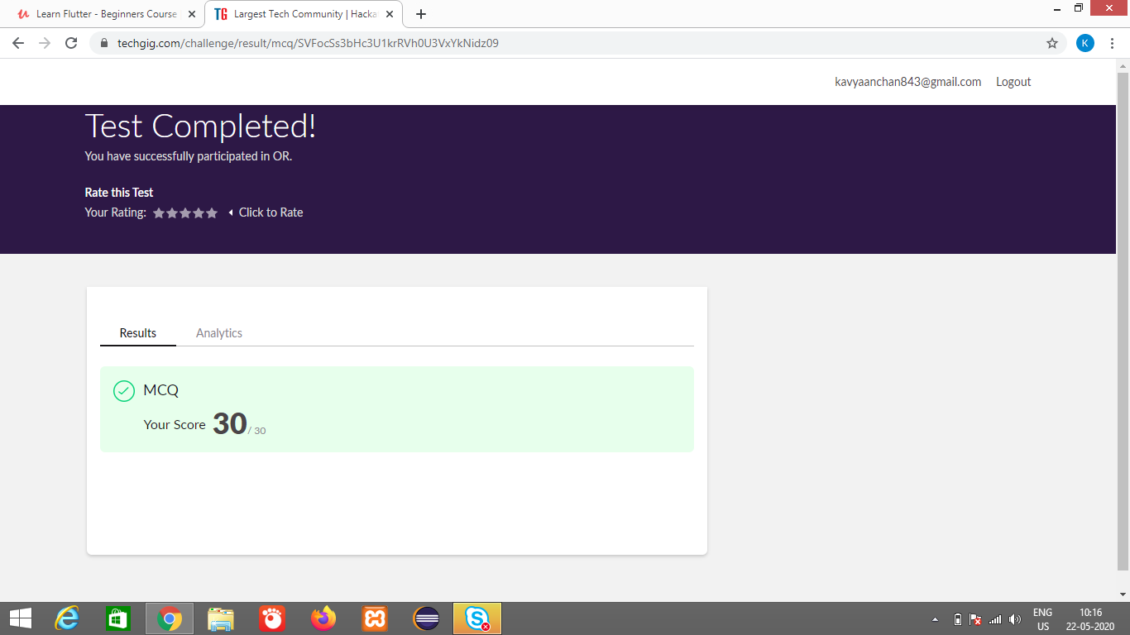

Certification Course Details: (Attach the snapshot and briefly write the report for the same)

***LEARN FLUTTER-BEGINNERS COURSE***

This course will teach us how to create  Flutter application in a very practical & simple manner, as every lecture comes with full coding screencast & corresponding code in notebook .

This course will be updates frequently as flutter and dart are in their early stages of development.

**What we’ll learn**

* Better understanding of flutter and it's basic widgets
* Develop basic flutter application for android and iOS

**Are there any course requirements or prerequisites?**

* Installed Android Studio/intellij/VSCode with flutter
* Basic knowledge of dart language
* Basic understanding of OOPS Concept

**Who this course is for:**

* Beginner flutter developers that are interested in developing mobile application for android and ios
* Developers that want to learn, how to create an mobile app using singlecode base**.**

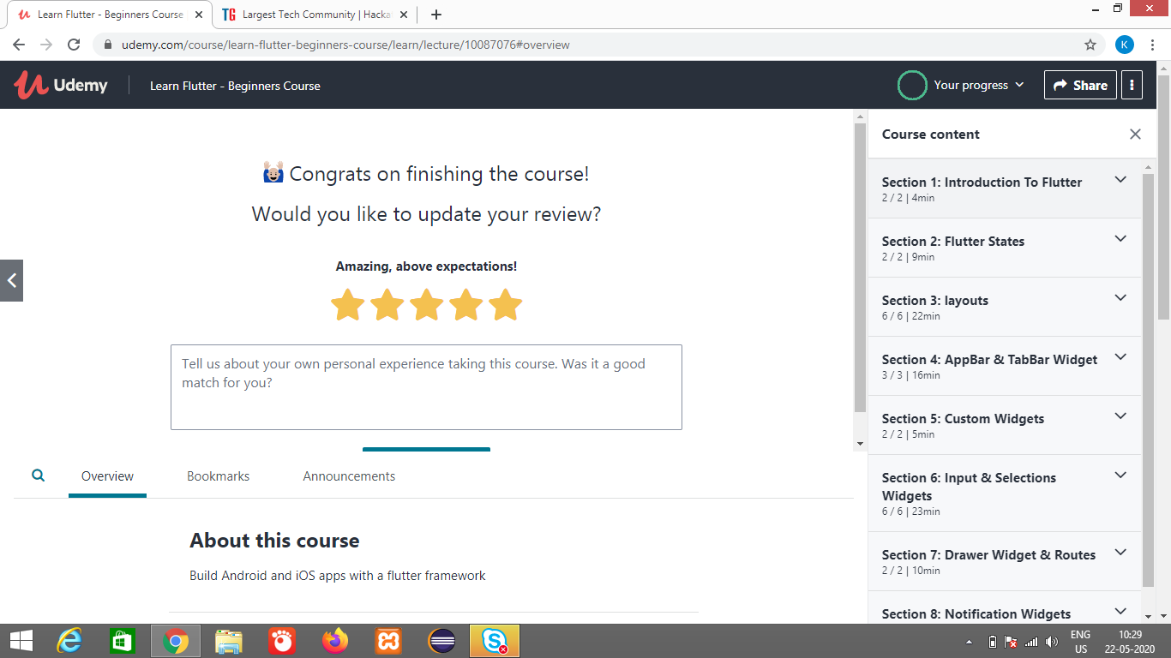

Its also uploaded in the repository

<https://github.com/kavya-077/DAILY-STATUS>

<https://github.com/alvas-education-foundation/kavya-onlinecourse>

Coding Challenges Details: (Attach the snapshot and briefly write the report for the same)

All the codes are executed in online GDE

And are uploaded in the repository <https://github.com/kavya-077/DAILY-STATUS>

<https://github.com/alvas-education-foundation/kavya-OCA>